**NAAN MUDHALVAN PROJECT**

**TO SUPPLY LEFTOVER FOOD TO POOR**

**DEPARTMENT OF COMPUTER SCIENCE**

**ST. JOSEPH’S COLLEGE FOR WOMEN**

**TIRUPUR-641 604**

**PRESENTED BY**

**TEAM MEMBERS**

**RASHITHA BANU .M -TEAM HEAD**

**KAVI NILAVU .R**

**SRI LEKHA .S**

**VINNARASI.A**

**LOGGING INTO SMART INTERNZ:**

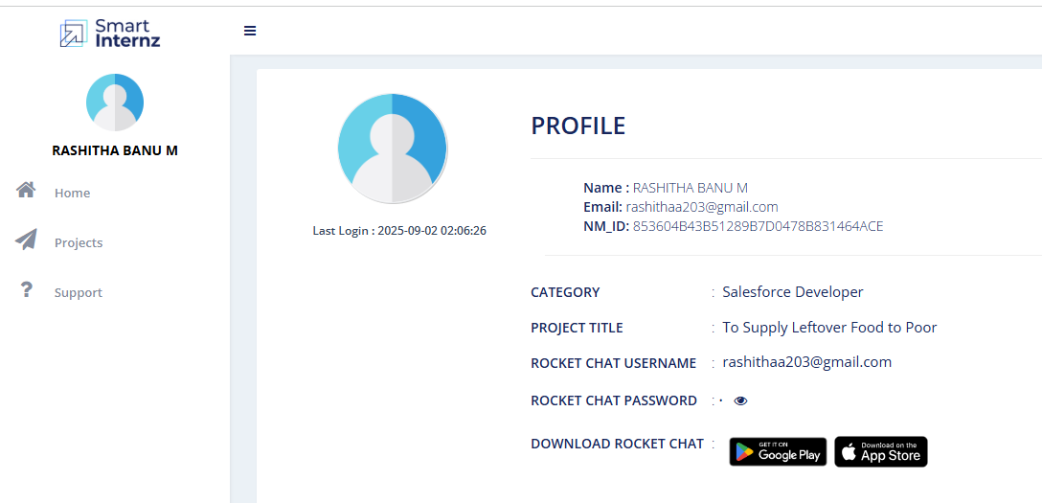

**CREATION OF DEVELOPER ACCOUNT AND ACTIVATION:**

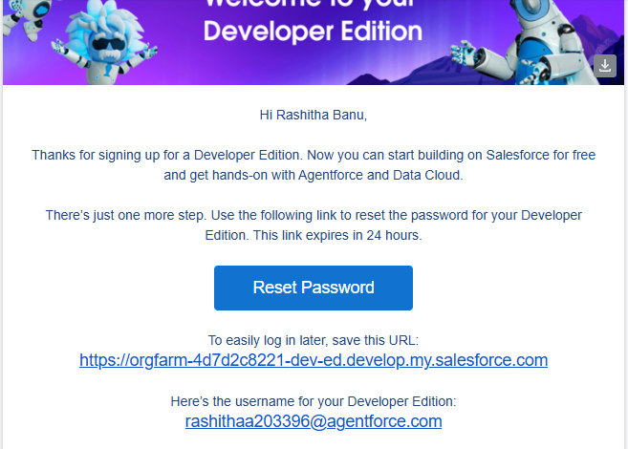

**CREATION OF OBJECTS:**

**VENUE OBJECT:**

**DROP OFF POINT OBJECT:**

**TASK OBJECT:**

**VOLUNTEER OBJECT:**

**EXECUTION DETAILS OBJECT:**

**CREATION OF CUSTOM TABS:**

**CREATION OF LIGHTNING FOOD CONNECT APP:**

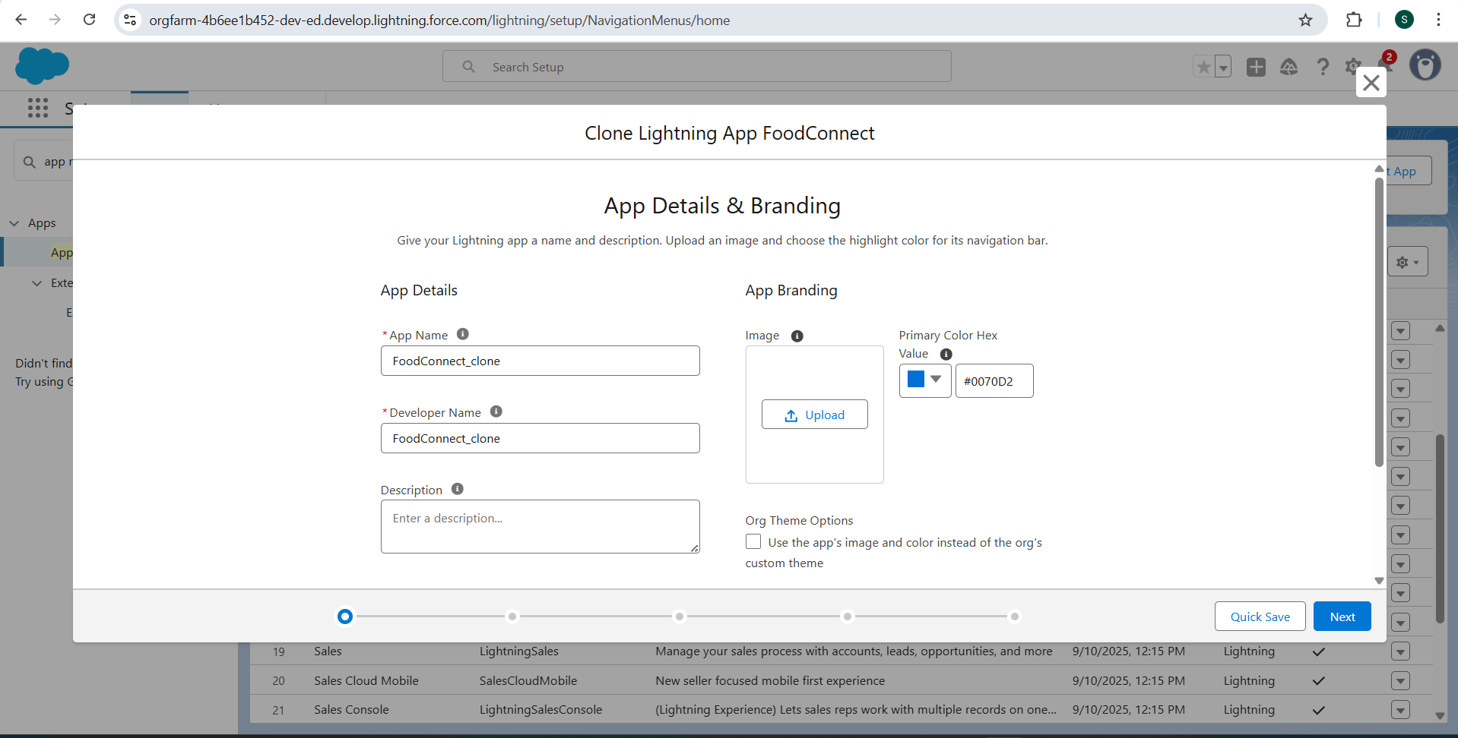

**CREATION OF FIELDS FOR VARIOUS OBJECTS:**

**VENUE OBJECT:**

**DROP OFF POINT OBJECT:**

**TASK OBJECT:**

**VOLUNTEER OBJECT:**

**EXECUTION DETAILS OBJECT:**

**CREATION OF FLOWS IN VENUE OBJECT:**

**VENUE FORM:**

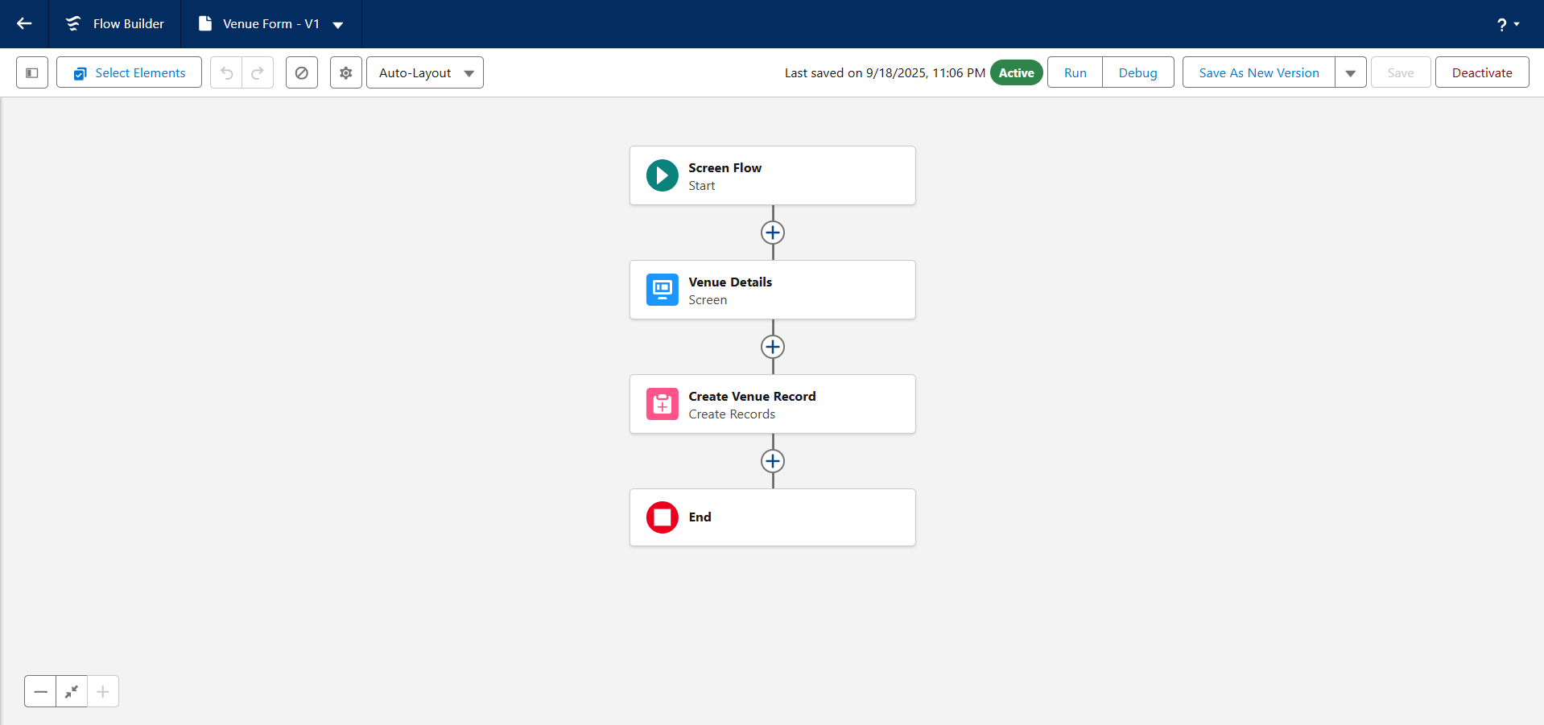

**CREATION OF TRIGGER AND ENTERING CODE:**

**CREATION OF PROFILES:**

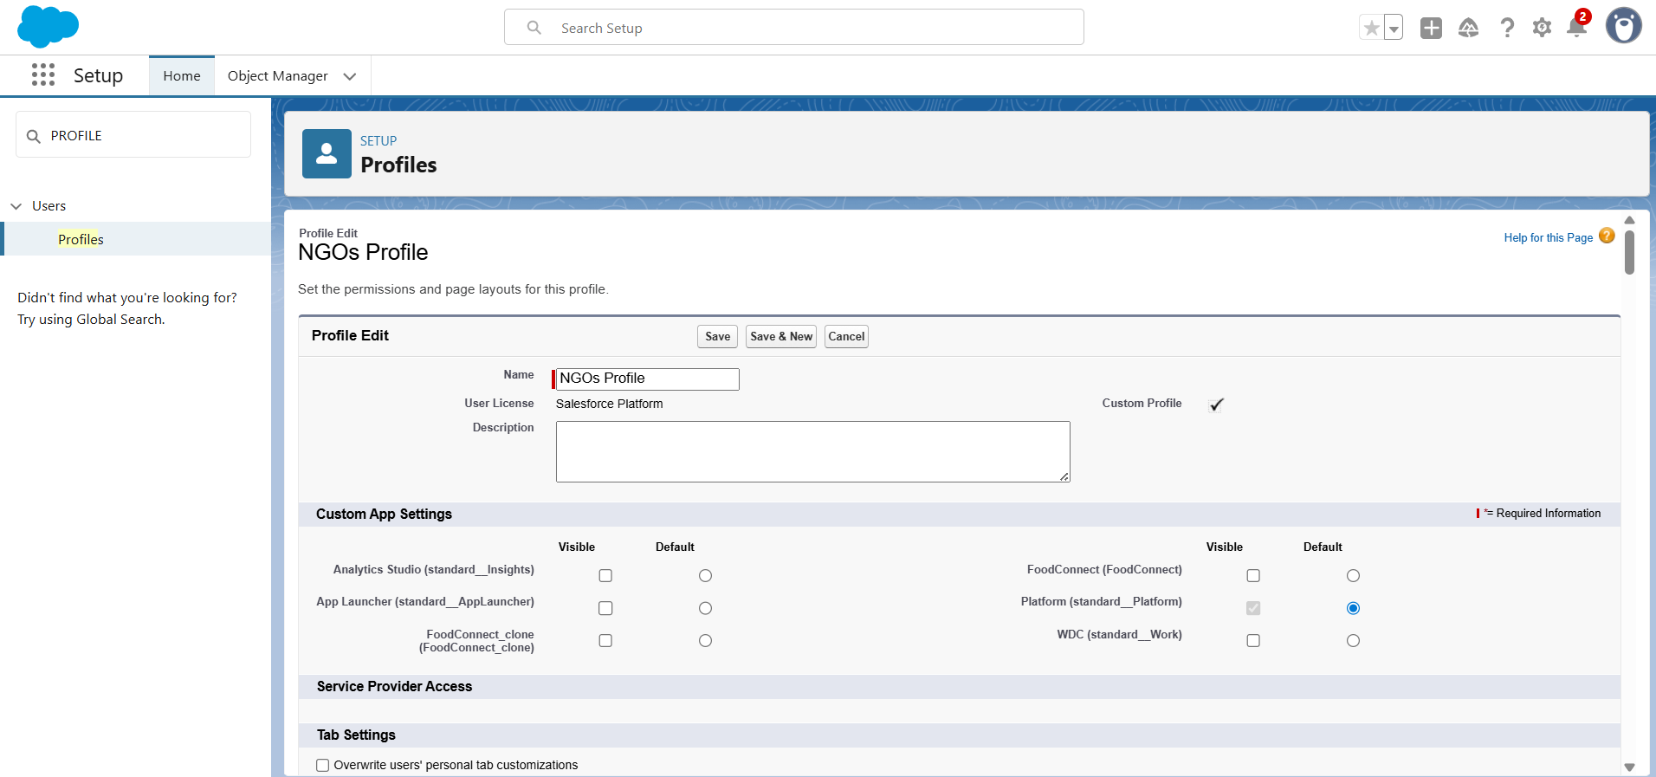

**CREATION OF USERS:**

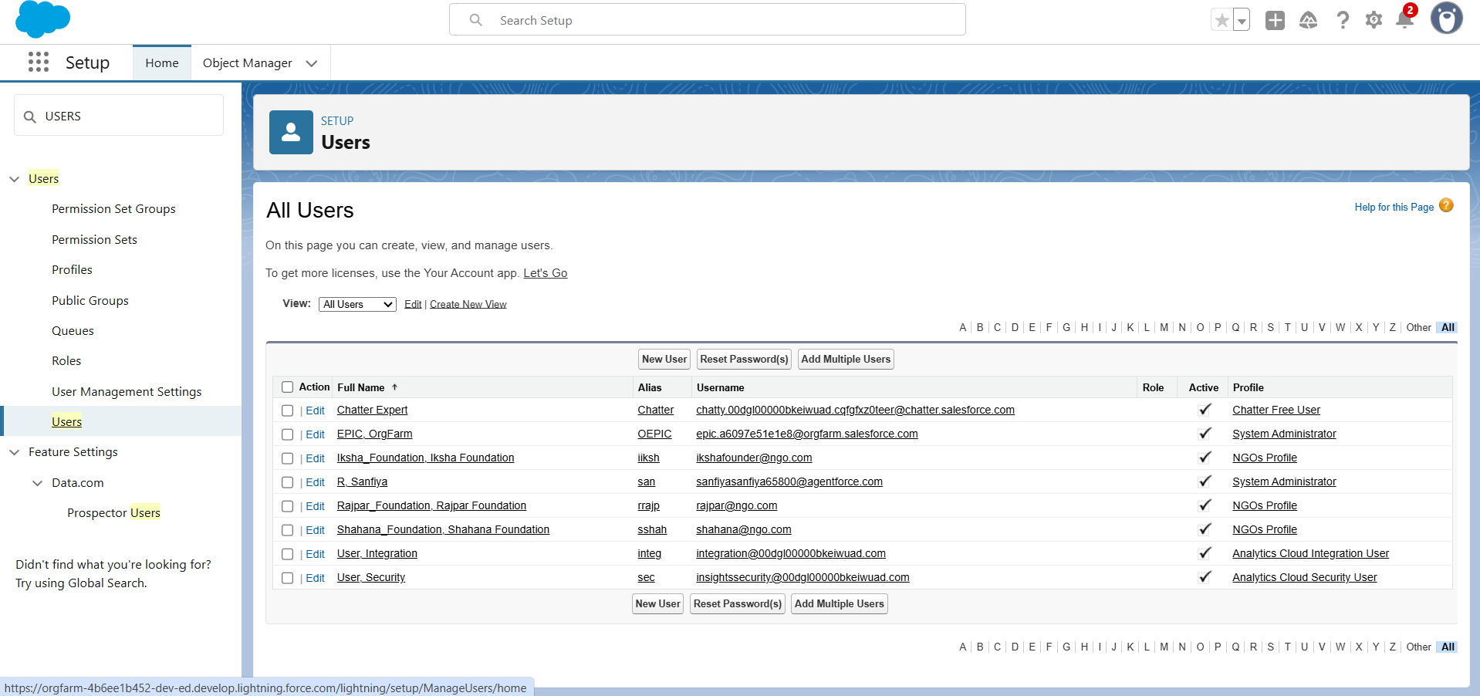

**CREATION OF PUBLIC GROUPS:**

**CREATION OF REPORT TYPES:**

**Venue With DropOff with Volunteer:**

**Volunteers with Execution Details and Tasks:**

**CREATION OF REPORTS ON VOLUNTEERS WITH EXECUTION DETAILS AND TASKS:**

**Overview:**

**CREATION OF DASHBOARD:**

**SHARING RULES:**

**Setting Three Rules for All the Group in DropOff Point Sharing Rules:**

**Conclusion:**

**CREATION OF HOME PAGE TO FOOD CONNECT APP:**

